PROJECT TITLE:
Simulation and Analysis of Piezoelectric Footstep Power Generation System
Abstract:
This project focuses on the analysis of a piezoelectric footstep power generation system based on its operating principle and electrical behaviour. The system converts mechanical energy generated from human footsteps into electrical energy using piezoelectric elements. When pressure is applied, the piezoelectric material produces an alternating voltage proportional to the applied force. This voltage is processed through a bridge rectifier to obtain a direct current output, which is then filtered and stored using energy storage components. The analysis emphasizes the relationship between footstep-induced vibration amplitude and frequency and the resulting generated voltage and power output, along with the influence of the sensor’s inherent capacitance and resistance on its electrical behaviour and overall performance. The results highlight the suitability of piezoelectric systems for low-power applications and serve as a foundational study for understanding footstep-based energy generation systems.
About Piezoelectric Effect and Piezoelectric materials:
The piezoelectric effect is a phenomenon in which certain crystalline materials generate an electrical charge when subjected to mechanical stress. This occurs due to the displacement of electric dipoles within the crystal lattice when an external force is applied. In the direct piezoelectric effect, mechanical energy is converted into electrical energy in the form of an alternating voltage. Piezoelectric materials such as quartz and lead zirconate titanate (PZT) are commonly used due to their high sensitivity and reliability. In footstep-based energy harvesting systems, the repeated application and release of pressure during walking produces an alternating electrical output, making piezoelectric materials suitable for converting human motion into usable electrical energy. The piezoelectric effect is extremely useful in a wide range of applications, particularly those involving the creation and detection of sound, the production of high voltages, and the generation of precise electronic frequencies. It is used in microbalances and in the ultra-fine positioning and focusing of optical components. This effect also underpins several advanced scientific instruments capable of atomic-scale resolution, such as scanning probe microscopes like STM and AFM. Beyond these high-tech uses, the piezoelectric effect appears in everyday devices too, for example providing the spark that ignites a cigarette lighter.
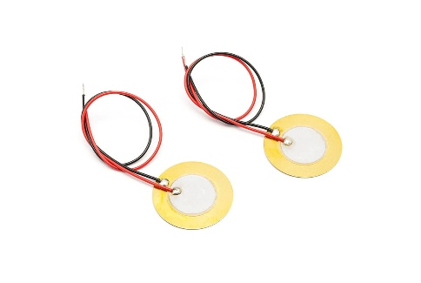

Piezoelectric Sensor:
A piezoelectric sensor is an instrument that converts mechanical effects such as pressure, force, vibration, strain, or acceleration into an electrical signal. The term “piezo” comes from the Greek word meaning to press or squeeze, which reflects the way these devices operate: when the material is mechanically stressed, it produces an electric charge. Electrically, the sensor behaves like a high-impedance voltage source combined with a filtering network. The generated voltage is proportional to the applied mechanical input, so larger forces or pressures create higher output voltages. The electrical output can therefore be analysed using an equivalent circuit that links the mechanical stimulus to the measured signal.

These sensors provide several important advantages. They can respond to very fast-changing inputs, allowing accurate detection of high-frequency or rapidly varying events. They also have excellent transient behaviour, meaning they can capture extremely short-duration phenomena while maintaining a nearly linear relationship between input force and output voltage. In addition, piezoelectric sensors produce sufficiently strong signals for easy electronic measurement, and their compact, robust structure makes them suitable for use in demanding environments.

Piezoelectric sensors are commonly made from three categories of materials: piezoelectric ceramics, single-crystal substances, and thin-film piezoelectric layers. Ceramic materials such as PZT and PVDF (Polyvinylidene Fluoride) generally exhibit much higher sensitivity than natural single crystals, often by around two orders of magnitude. To compare material performance, voltage–current characteristics can be recorded while applying different mechanical loads. By measuring the voltage across the material and the resulting current through it as the applied force changes, the electrical response of each material type can be evaluated, showing how different stresses lead to different electrical outputs.

According to a study, the material was chosen based on which one produced a higher output voltage when different pressure levels were applied. To compare their behaviour under varying forces, the voltage–current (V–I) responses of two materials, PZT and PVDF, were measured and plotted. For these tests, the piezoelectric sample being evaluated was mounted on a piezoelectric force sensor so that controlled mechanical loads could be applied and the corresponding electrical output could be accurately recorded. The measurements show that the PZT material produces an output of about 2 V, while the PVDF material generates only around 0.4 V under the same conditions. This indicates that PZT delivers a significantly higher electrical response, making it the more effective choice when a larger output voltage is required.
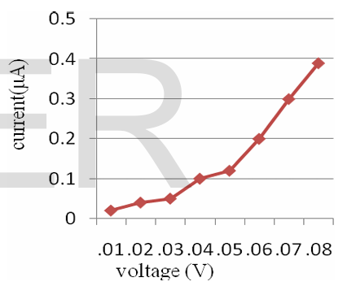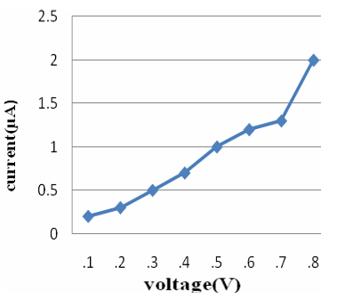

FIG 1: V-I GRAPH OF PZT MATERIAL FIG 2: V-I GRAPH OF PVDF

Connection Configurations and how they affect the output efficiency:
In a series connection, the voltages produced by each sensor are added together. This implies that the resulting output voltage is increased compared to the single sensor voltage, but the current is still limited. This type of connection is ideal for applications that aim to achieve a higher voltage level to overcome the circuit thresholds, but it is not ideal for applications requiring more power to be delivered to the load, as the current is limited.
In a parallel connection, the currents produced by each sensor are added together. The voltage level remains almost the same as in the single sensor case. This implies that the current output is strengthened, making it ideal for applications requiring more current rather than higher voltage levels.
A combination of both series and parallel connections can be applied to achieve a balance of both effects. This can be achieved by combining sensors in series to increase the voltage level and then connecting the resulting groups in parallel to increase the current output, making it ideal for energy harvesting applications.
The need for rectifier circuit:
A piezo element will not create a constant DC voltage when it is pressed or vibrated. Rather, it will create an alternating signal that oscillates between positive and negative as the material bends back and forth. Most electronic circuits and storage devices, such as capacitors, batteries, and microcontrollers, need a one-way (DC) voltage to function.
A rectifier is thus introduced to change the piezo’s AC signal to DC. It will only allow current to flow in one direction, thereby causing both the positive and negative parts of the vibration cycle to be converted into positive pulses. There are two significant advantages to this: the negative cycles will no longer cancel out the positive cycles, and the energy will be stored in a capacitor rather than charging and discharging. A bridge rectifier changes the AC output into a single-direction voltage, but the signal still contains fluctuations called ripples. To make the output smoother, a capacitor is connected after the rectifier.
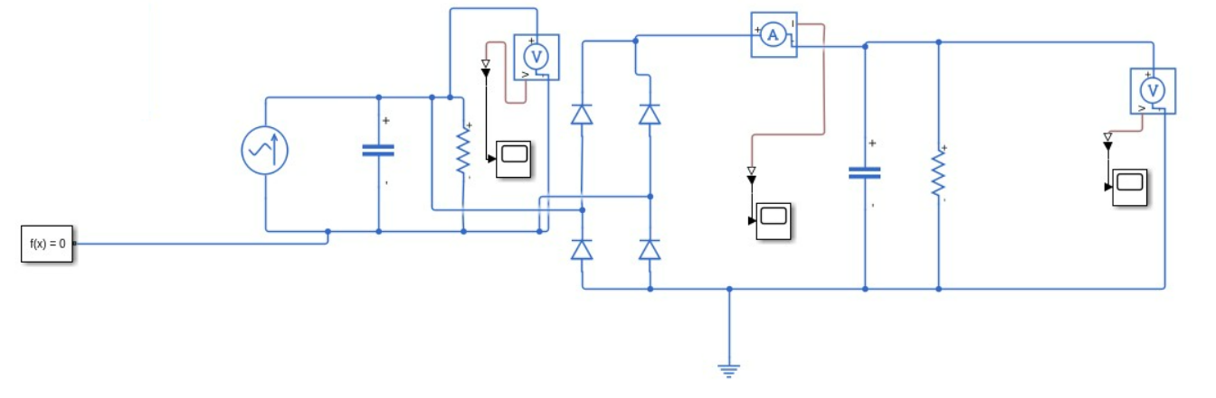
FIG 3: PIEZOELECTRIC SENSOR ENRGY HARVESTOR SIMULATION
SIMULATION AND ANALYSIS:
The piezoelectric sensor is modelled and simulated in Simscape to precisely analyse its behaviour under different vibration strengths and frequency ranges. The sensor's output voltage varies depending on the passive elements—specifically its resistance and capacitance—as well as the frequency and amplitude of the applied vibration.
ELECTRICAL EQUIVALENT OF THE PIEZOELETRIC SENSOR
The electrical equivalent circuit of a piezoelectric sensor can be modelled using a charge current source in parallel with a capacitor and a high-value resistor. The high-value resistor indicates the low leakage current, and the high output impedance is due to the parallel connection of the capacitance. Due to the presence of the capacitance, the sensor has a much higher impedance than the frequencies of the data acquisition system.
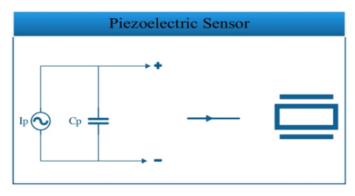

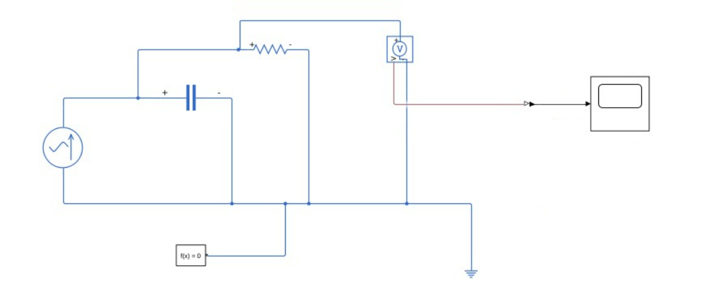

FIG 4: PIEZOELECTRIC SENSOR SIMULATION

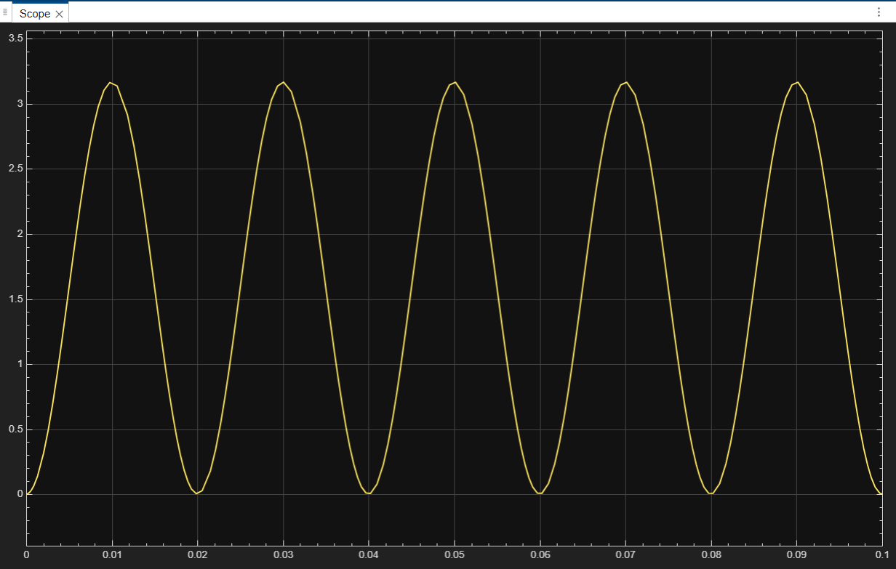
FIG 5: PIEZOELECTRIC SENSOR OUTPUT VOLTAGE AT 50 MICRO AMPERE IIN AND 60 HZ FREQUENCY, V-T GRAPH.

TESTING AND OBERVATIONS:
Effect of Vibration Strength
To verify the effect of vibration strength on the output voltage:
The input vibration signal was simulated using a sine wave source, with the amplitude denoting the strength of the vibration. The frequency was held constant while the amplitude was changed in a series of simulation runs. The output voltage was measured using a Scope or Simscape Results Explorer.
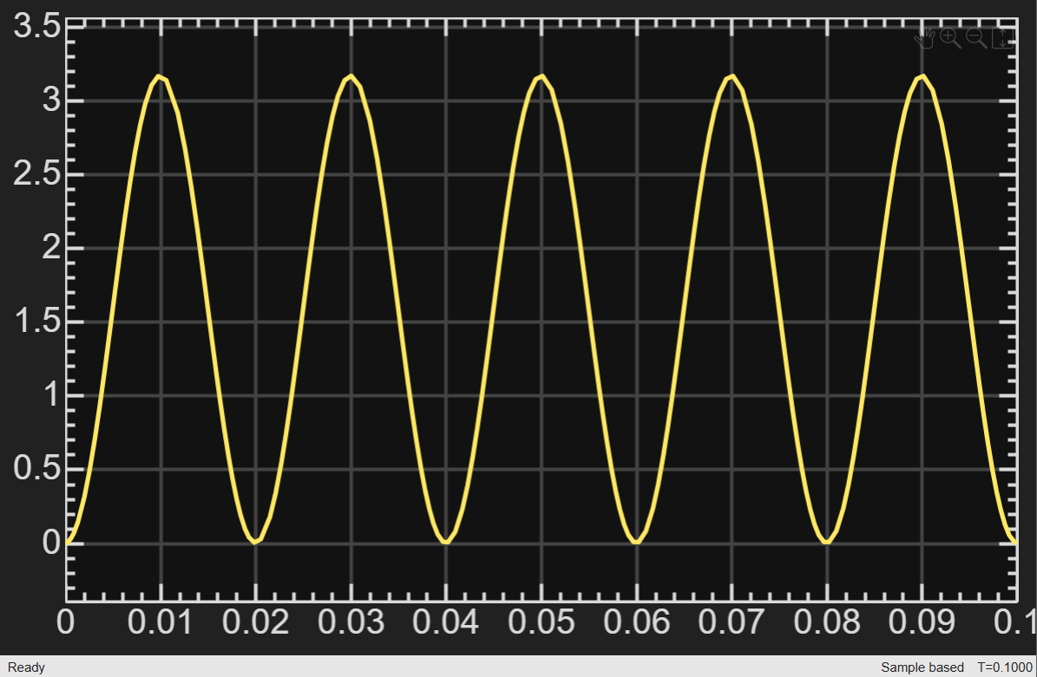
FIG 6: PIEZOELECTRIC SENSOR OUTPUT VOLTAGE AT 50 MICRO AMPERE IIN AND 50 HZ FREQUENCY, V-T GRAPH.

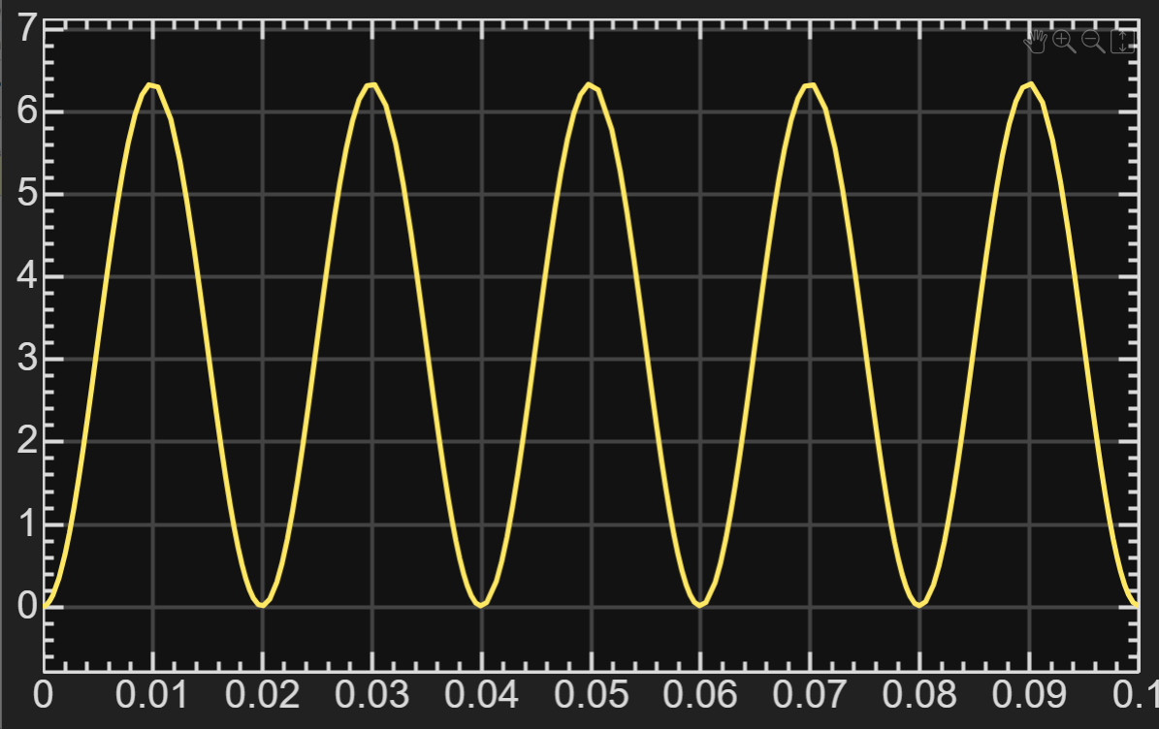
FIG 7: PIEZOELECTRIC SENSOR OUTPUT VOLTAGE AT 100 MICRO AMPERE IIN AND 60 HZ FREQUENCY, V-T GRAPH.

Observation:
The simulation results indicated that with the increase in vibration strength, there was a proportional increase in the output voltage. As the input vibration strength was varied gradually while maintaining other variables constant, the output voltage waveform indicated a corresponding increase in the peak value. This indicated that with the increase in mechanical stress on the piezoelectric material, there was an increase in the electrical charge, resulting in an increase in the output voltage.
Effect of Vibration Frequency:
To study frequency dependence:
The vibration amplitude was held constant. The frequency of the sine wave input was varied over a predetermined range (low to high frequency). The output voltage was measured for each frequency.
Observation:
The experimental results indicated a strong dependence of the output voltage on the vibration frequency. At lower frequencies, the output voltage was low due to the leakage of charge through the internal resistance. As the frequency was increased, the output voltage also increased, indicating less leakage and more accumulation of charge. A peak in the output voltage was noticed around the resonance frequency, indicating that there was a higher electromechanical coupling at higher frequencies.
Effect of Sensor Capacitance:
In a real piezoelectric sensor, the capacitance is a measure of the ability of the piezoelectric material to store electric charges due to mechanical stress.
To check the effect of capacitance:
The capacitance of the parallel capacitor was changed by varying the capacitance value while keeping the vibration amplitude and frequency unchanged. Different simulations were performed for different values of capacitance. The output voltage waveforms were compared.
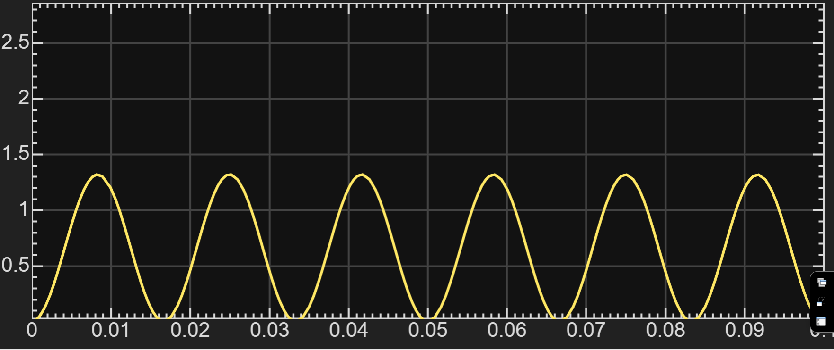
FIG 7: PIEZOELECTRIC SENSOR OUTPUT VOLTAGE AT C=200 MICRO FARAD AT 50 MICRO AMPERE AMPLITUDE AND 60 HZ FREQUENCY, V-T GRAPH.

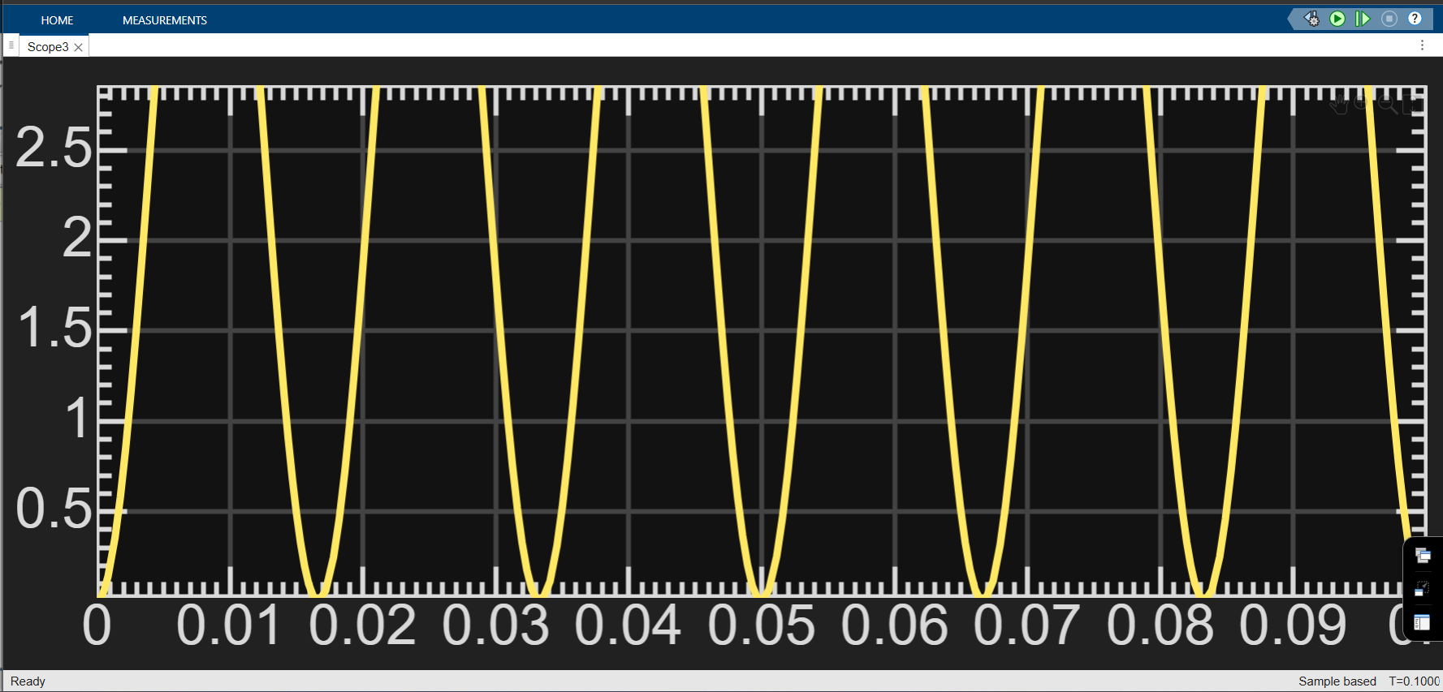
FIG 7: PIEZOELECTRIC SENSOR OUTPUT VOLTAGE AT C=50 MICRO FARAD AT 50 MICRO AMPERE AMPLITUDE AND 60 HZ FREQUENCY, V-T GRAPH.
Observation:
By changing the capacitance value in the Simscape model, it was noticed that as the capacitance value increased, the output voltage decreased for a given vibration input. On the contrary, as the capacitance value decreased, the output voltage was seen to increase. This experiment clearly shows the inverse relationship between capacitance and voltage for a given charge generated and proves the theoretical characteristics of piezoelectric sensors.
\
Impact of Resistance on the Sensor
The resistance is a measure of the leakage current paths in the piezo material and the insulation of the sensor. The effect of resistance was confirmed by simulating various resistance levels under constant vibration conditions.
To check the effect of resistance:
The parallel resistance was changed by varying the resistance value over different ranges of high values. Simulations were carried out for low and high vibration frequencies. The output voltage decay and steady-state values were checked.
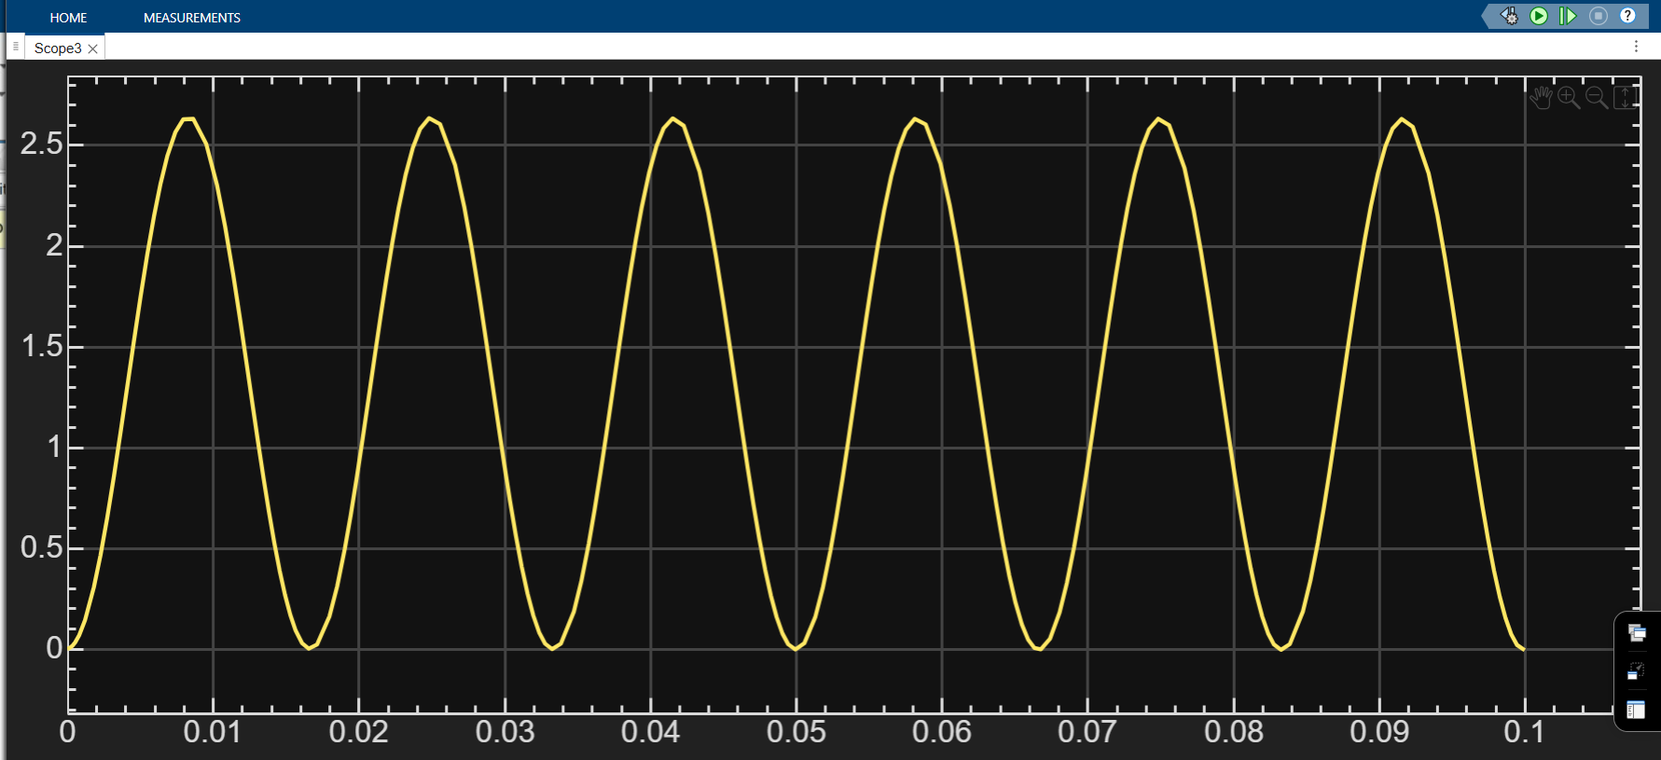
FIG 8: PIEZOELECTRIC SENSOR OUTPUT VOLTAGE AT R=100 MEGA OHM AT 50 MICRO AMPERE AMPLITUDE AND 60 HZ FREQUENCY, V-T GRAPH.

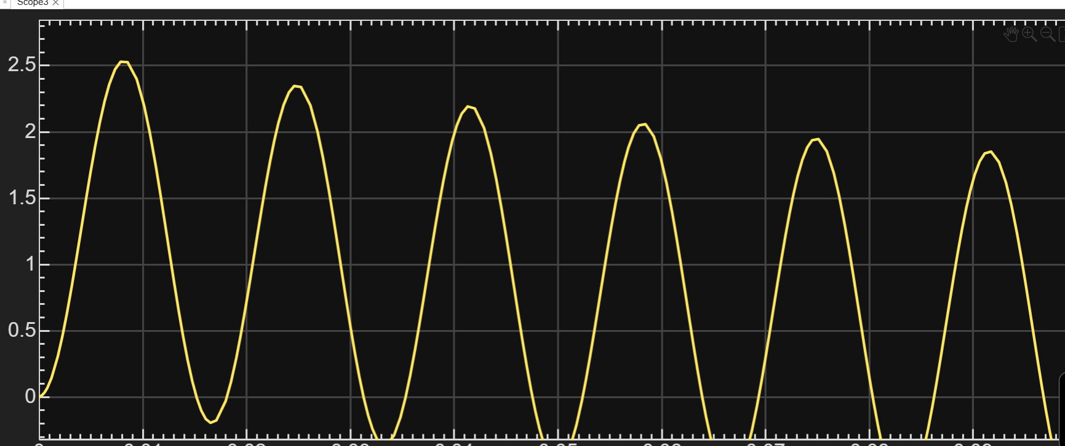
FIG 9: PIEZOELECTRIC SENSOR OUTPUT VOLTAGE AT R<1 MEGA OHM AT 50 MICRO AMPERE AMPLITUDE AND 60 HZ FREQUENCY, V-T GRAPH.

Observation:
Fig 9 shows that the lower and attenuated output voltage at very low resistance values is attributed to the charge leakage that occurs due to the small RC time constant, which is not sufficient for the voltage to build up across the piezoelectric capacitance.
Higher resistance always resulted in higher output voltages, especially at lower frequencies, because of less charge dissipation. However, lower resistance levels resulted in faster charge dissipation, causing a noticeable reduction in the output voltage. These results experimentally validate the effect of resistance on the retention of charges in the sensor.

RESULTS:
The simulation outcome reveals that the output voltage of the piezoelectric sensor increases with the amplitude of the footstep-induced vibration, thus establishing a direct relationship between the mechanical input and the electrical output of the sensor. The sensor output was also observed to be a function of frequency, with lower frequencies resulting in lower voltages due to the leakage of charges, whereas higher frequencies resulted in better voltage development. The variations in the capacitance of the crystal established an inverse relationship with the output voltage, with higher capacitance resulting in lower voltage magnitudes. Higher leakage resistance was also observed to improve the voltage retention capability, especially at lower frequencies, thus establishing its importance in the electrical output of the sensor.

FUTURE SCOPE: ALTERNATIVE ENERGY SOURCES:
The future work that can be done on this topic is the harvesting of energy from the impact of raindrops on piezoelectric sensors. Like footstep-generated vibrations, the mechanical energy generated from the impact of raindrops on a surface can be converted into electric energy using properly designed piezoelectric sensors. Future work can be done on improving the sensitivity of the sensor, the capacitance of the crystal, and the leakage resistance to properly harness the low-force, high-frequency impact of raindrops. These systems can be installed on rooftops, water harvesting surfaces, or solar panels to provide supplementary power to low-energy devices and environmental monitoring networks in areas with high rainfall.

CONCLUSION:
This work proves that piezoelectric footstep energy harvesting systems are capable of efficiently harvesting mechanical vibrations to produce electrical energy, which is highly dependent on the amplitude, frequency, and capacitance/resistance of the sensor. The results show that higher forces and optimal frequencies result in higher output voltages, while capacitance and resistance affect the retention of charge and stability of the output voltage, especially at low frequencies. These results confirm the theoretical response of piezoelectric sensors and the need for careful sensor design to ensure maximum energy is harvested. This work serves as a basis for future studies aimed at optimizing material properties, sensor design, and the investigation of other mechanical sources such as raindrops, wind, or industrial vibrations to widen the scope of sustainable energy harvesting.

REFERENCES:
- A review on piezoelectric ceramics and nanostructures: fundamentals and fabrications Research (Published: 26 January 2024)

- Piezoelectric Transducer: Concept & Modeling - Prof. Roozbeh Tabrizian Department of Electrical and Computer Engineering University of Florida

- Thermoelectric, piezoelectric and photovoltaic harvesting technologies for pavement engineering.

